
Department of Artificial Intelligence and Machine Learning
QUESTION BANK FOR IV Sem (Term: Feb-June 2026)
Algorithms Laboratory (AIL46)
Note:
1) For the questions in (a) that is related to asymptotic bounds program should be written and for the rest algorithm should be written.
2) Programs can be written or implemented using C / C++/ Java programming language.
3) The built-in modules should not be used for implementation (except time module and random module)
Sl.No | Questions | CO Mapping
 | - Given f(n)= 8n2+3n+3, Write a program to prove that f(n)= Ω(n) and find the n0 value. Plot a graph for f(n) and c*g(n) where c is a constant and for varying n values (10 to 30).  - A car driver is given a set of locations to be covered with their distances by a company. Now the company gives a privilege for the car driver to start at any arbitrary location. But, the condition is the route chosen by the driver should be minimum i.e. the total cost of the entire driving should be minimum.  Design and implement an algorithm that gives a greedy solution to the car driver and display the minimum cost achieved. State the design strategy used and time complexity of the same.  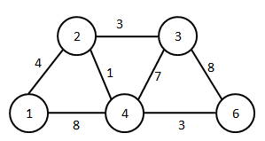 | CO3
 | - Given f(n)= 6n2+2n+2, Write a program to prove that f(n)= O(n2) and find the n0 value. Plot a graph for f(n) and c*g(n) where c is a constant and for varying n values (10 to 30).  - A phone company wants to lay lines for communication in a city. Different amounts are charged for connecting between a pair of cities.  Design and implement a greedy solution such that it forms a spanning tree with minimum cost. State the design strategy used and time complexity of the same.  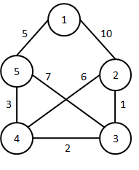 | CO3
 | - Given f(n)= 4n2+3n+5, Write a program to prove that f(n)= θ(n2) and find the n0 value. Plot a graph for f(n), c1*g(n)and c2*g(n) where c1, c2is a constant and for varying n values (10 to 30).  - Alia is planning for a trekking expedition with a backpack that can hold 7kg. She needs to select the most valuable items from the following list that can be accommodated within the backpack.  Design and implement an algorithm that displays the most valuable items that can be carried by him using Dynamic programming principles. State the design strategy used and time complexity of the same.  Items Weight Value  1 3 10  2 5 4  3 6 9  4 2 11 | CO3
 | - Given f(n)= 5n2+6n+3, Write a program to prove that f(n)= θ(n2) and find the n0 value. Plot a graph for f(n), c1*g(n)and c2*g(n) where c1, c2is a constant and for varying n values (10 to 30).  - A drama venue needs to be allocated for different drama school requests such that maximum profit is obtained for the company owning the drama venue. The requests are shown in the table with start–time, finish-time and the amount affordable by the drama school. Design and implement an algorithm such that maximum profit is obtained for the company owning the drama venue using Dynamic programming principles. State the design strategy used and time complexity of the same.  Drama School Start- time Finish- time Value  1 1 2 100  2 2 5 200  3 3 6 300  4 4 8 400  5 5 9 500  6 6 10 100 | CO3
 | - Given f(n)= 8n2+3n+3, Write a program to prove that f(n)= Ω(n) and find the n0 value. Plot a graph for f(n) and c*g(n) where c is a constant and for varying n values (10 to 30).  - Design and implement Bellman ford algorithm to find the shortest path from a given source to all other nodes using dynamic programming. State the design strategy used and time complexity of the same.  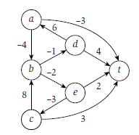 | CO3
 | - Given f(n)= 3n2+4n+3, Write a program to prove that f(n)= Ω(n) and find the n0 value. Plot a graph for f(n) and c*g(n) where c is a constant and for varying n values (10 to 30).  - In a database of numbers there is a table of unsorted numbers. The database admin now wants to sort these numbers using an approach wherein a pivot element is selected for sorting. At certain point, the first half elements are less than the pivot and right half elements are greater than the pivot. Design and implement an algorithm to solve it using random numbers and also display the execution time. State the design strategy used and time complexity of the same. | CO3

